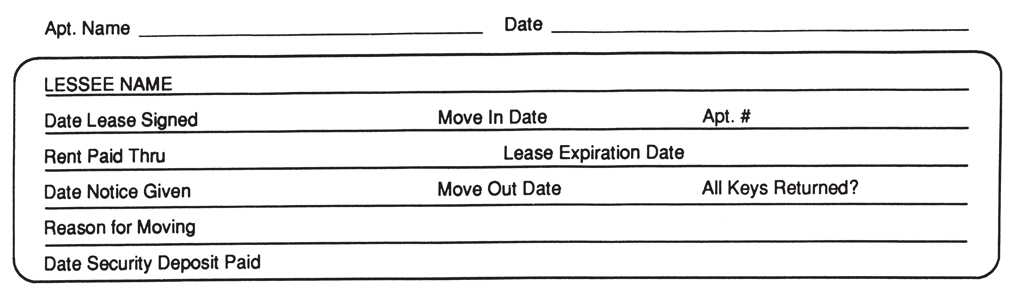
SECURITY DEPOSIT SETTLEMENT

 | Current Ledger Balance due / (credit) | $
 | Additional Charges (not on ledger)
 | Lease Violation | $
 | Late fees, Court Costs | $
 | Repairs & Missing Items | $
 | Cleaning | $
 | Keys | $
 | Miscellaneous | $
 | TOTAL DEDUCTIONS | $
 | From Tenant / (To Tenant) BALANCE DUE | $

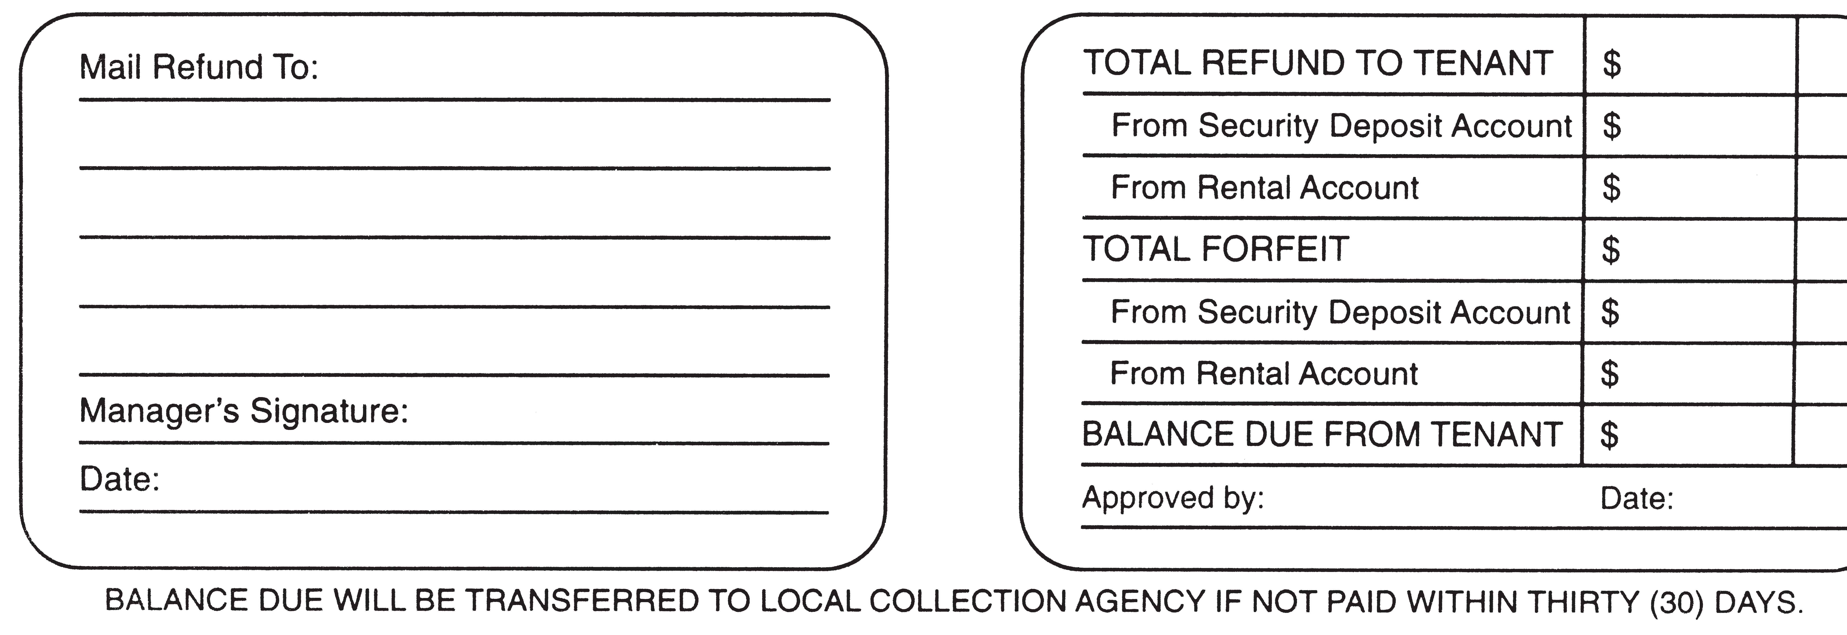
This institution is an equal opportunity provider and employer-This is an attempt to collect a debt
(Current if no forward provided)
HOME OFFICE USE ONLY
SD Allocation 1191/1700 $
Check # Paid
SD Refund
1191/2191
$
Check # Paid
Other 1120/
Check # Paid
Approved Date

